**Caesar Cipher**

## Introduction [§](http://practicalcryptography.com/ciphers/caesar-cipher/#introduction)

The Caesar cipher is one of the earliest known and simplest ciphers. It is a type of substitution cipher in which each letter in the plaintext is 'shifted' a certain number of places down the alphabet. For example, with a shift of 1, A would be replaced by B, B would become C, and so on. The method is named after Julius Caesar, who apparently used it to communicate with his generals.

More complex encryption schemes such as the [Vigenère](http://practicalcryptography.com/ciphers/classical-era/vigenere-gronsfeld-and-autokey/) cipher employ the Caesar cipher as one element of the encryption process. The widely known ROT13 'encryption' is simply a Caesar cipher with an offset of 13. The Caesar cipher offers essentially no communication security, and it will be shown that it can be easily broken even by hand.

CODE :

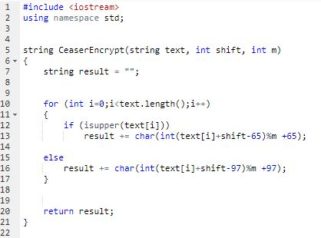

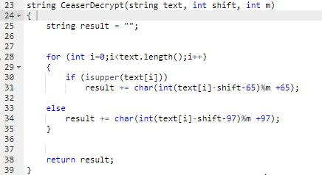

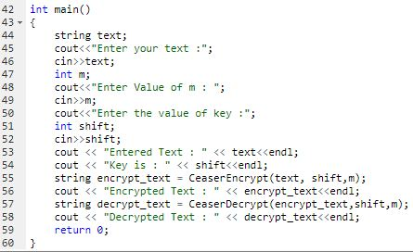

Output :

